Technical SEO

**1.SSL Certificate**

Zerossl---->get free ssl---->new certificate--->

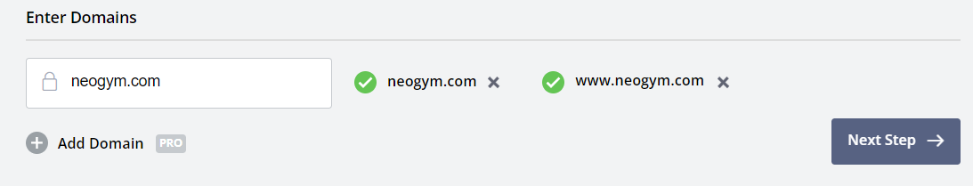

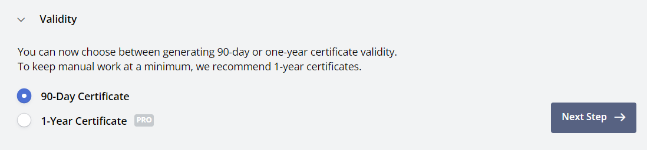

```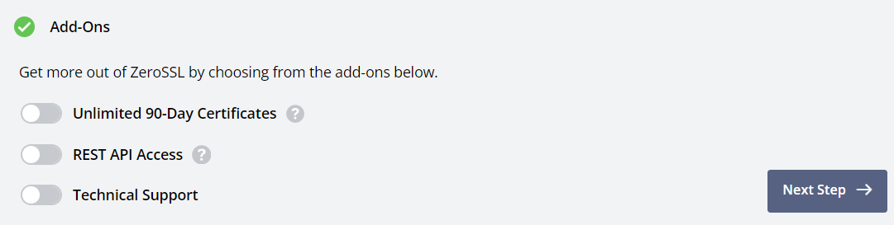

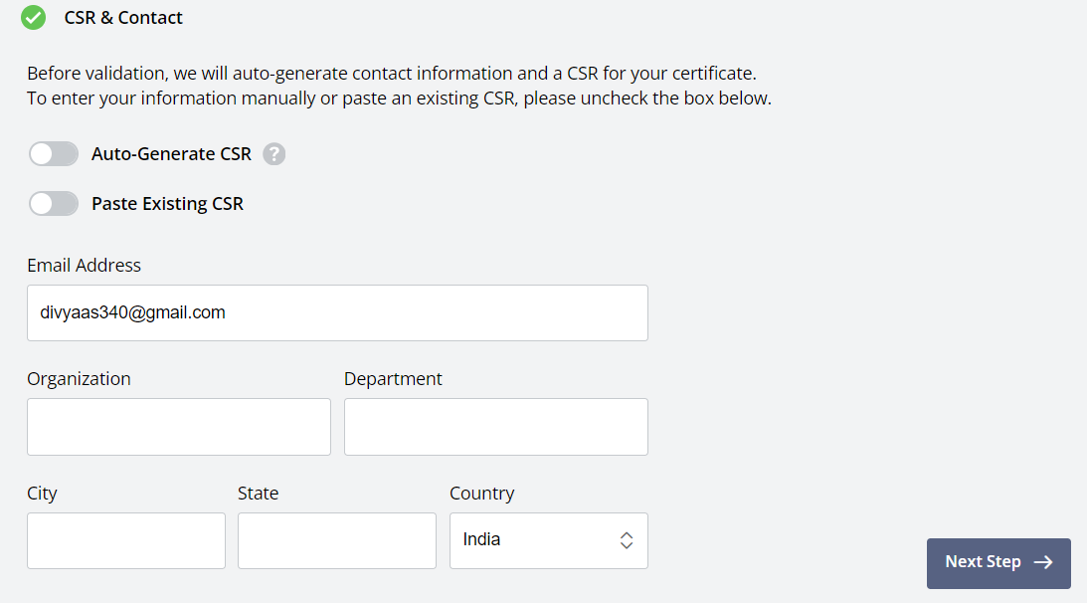

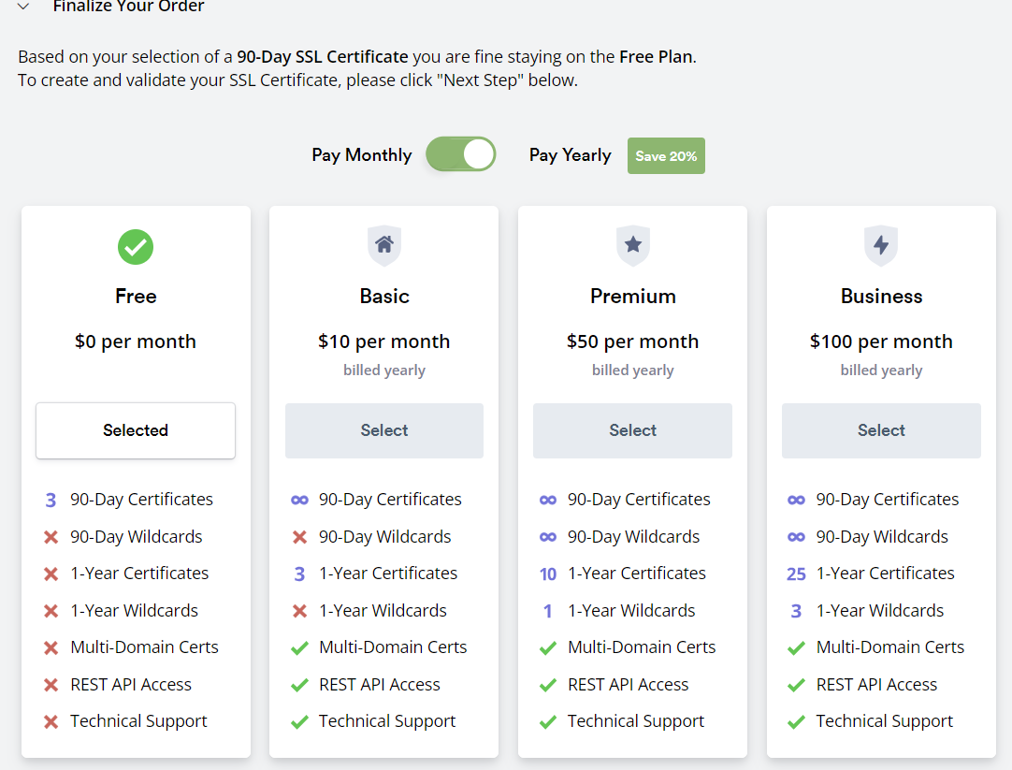

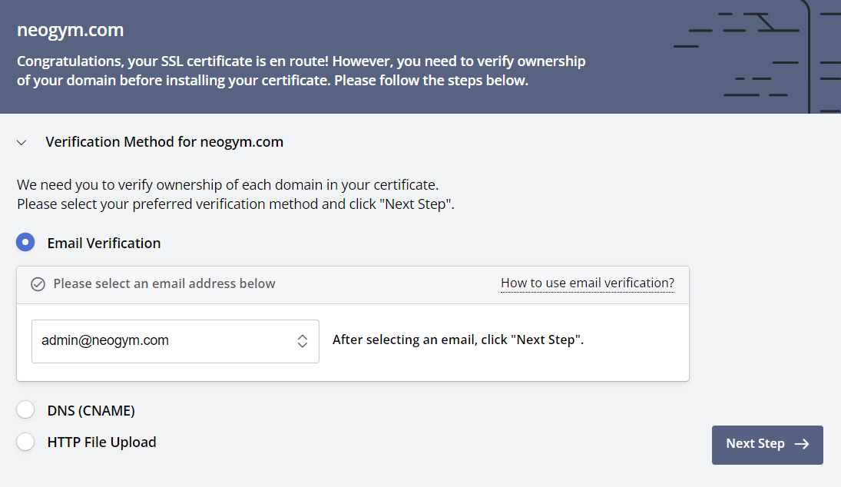

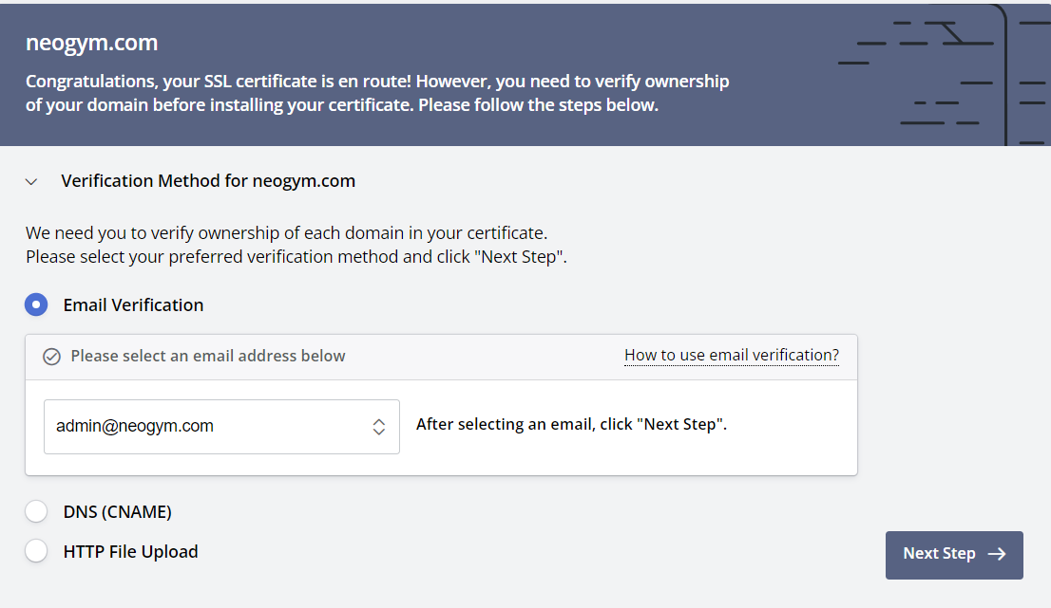

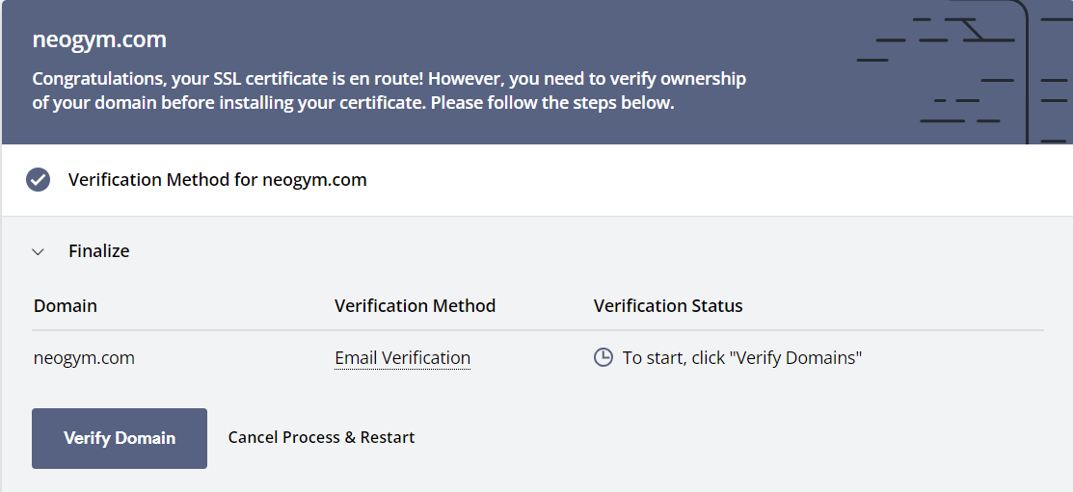

**2.Robots.txt File**

* The robots.txt is a text file that tells to search engines which pages on your site to crawl and which pages not to crawl.
* The robots.txt, also known as the robots exclusion protocol.
* The contents of a robots.txt are publicly available in the Internet, anyone can

**How does robots.txt work?**

The robots file has a very simple structure. There are some

predefined keyword combinations you can use.

The most common are:

1. User-agent

2. Disallow

3. Allow

4. Crawl-delay

5. Sitemap

**1. User-agent**

* All search engines identify themself a user-agent.
* You can use an to all crawlers or specify the name of a crawler

**Examples:**

User-agent: * --------- includes all crawlers.

User-agent: Googlebot -------- instructions for Google bot. Bingbot, msnbot, Twitterbot, Applebot

**2. Disallow**

* The Disallow directive that instructs a user-agent not to crawl a URL or part of a website.

**Examples:**

Disallow: /wp-admin/

Disallow: /service/

**3. Allow**

* You can use the allow to give access to a specific sub-folder on your website, even though the parent directory is disallowed.

**Examples:**

User-agent:

Disallow: wp-admin/image

Allow: /image/seo/

**4. Crawl-delay**

* You can specific a crawl-delay value to force search engine crawlers to wait for a specific amount of time before crawling the next page from website.
* You can use this when your website is running on a poor hosting environment
* The value you enter is in milliseconds.

**Examples:**

User-agent:

crawl-delay: 10

**5. Sitemap**

* The sitemap directive is supported by the all major search engines
* If you already submitted your XML sitemap in Google Search Console or Bing Webmaster Tools. There are more search engines out.

**Examples:**

User-agent:

Disallow:

Sitemap: <https://example.com/sitemap.xml>

Free Robots.txt Generator

<https://simplifiedseotools.com/robots-txt-generator>

**3.XML Sitemap Submission**

* A sitemap is a blueprint of website. It's containing information about the pages, videos and other files on your website
* Search engines use sitemaps to find and crawl website pages, then add them to search results for a specific keyword
* A sitemap can have up to 50,000 URLs and a file size of up to 50MB.

**Structure of an XML sitemap**

<urlset>, </urlset> ------- Protocol type

<url>, </url> ---------- Its indicate the listed subpage.

<loc>, </loc> ---------- Identifies the individual pages

<lastmod>, </lastmod> ------------ The page's last modification

<priority>, </priority> ---------- URL's priority within an entire website

**How to Generate & Submit XML Sitemap**

There are two ways:

1. Submit your XML sitemap in Google Search Console & Bing Webmaster Tools

2. Add your sitemap in robots.txt

User-agent: *

Allow: /

Sitemap: <https://domain.com/sitemap.xml>

**4.What is 301 (Permanent) Redirect**

* The 301 status code means that a page has permanently moved to a new location.
* 301 redirect passes all ranking power from the old URL to the new URL
* It tells the users and search engines that the original page is no longer available and all the information is shifted to a new page.

**When Should Use a 301 Redirect**

1. To redirect visitors after you've moved to a new domain

2. To redirect visitors after you've moved old site pages to a new site structure

3. To redirect visitors to new pages after you've combined two sites

**.htaccess Code**

Redirecting a Single URL:

<IfModule mod_rewrite.c>

RewriteEngine On

Redirect 301 /oldpage.php <http://www.domain.com/newpage.php>

</IfModule>

Redirecting a Single Folder:

RewriteRule ^/?folder/(.*)$ /location/$1 [R,L]

Redirecting www to Non-www:

RewriteCond %{HTTP_HOST} ^(.*)$ <http://example.com/$1> [L,R=301]

**5.What is 302 (Temporary) Redirect**

* 302 redirect is a temporary redirect. This is useful for SEO purposes when you have a temporary landing page and plan to switch back to your main landing page at a later date.
* It tells the users and search engines that the original page is shifted to a new page.
* 302 redirect keeps all ranking power from the old URL to the new URL

**When Should Use a 302 Redirect**

1. A/B testing of a web page for functionality or design.

2. To redirect visitors after you've moved to a new domain

3. To redirect visitors after you've moved old site pages to a new site structure

4. To redirect visitors to new pages after you've combined two sites

**.htaccess Code**

Redirecting a Single URL:

<IfModule mod_rewrite.c>

RewriteEngine On

Redirect 302/oldpage.php <http://www.domain.com/newpage.php>

</IfModule>

Redirect your entire website to a different URL

Redirect 302/<http://newwebsitehere.com/>

**6.Custom 404 Redirections**

* A 404 error is a code that indicates a requested page cannot be found. Google doesn't index pages that return a 404 status
* Custom 404 pages will really help your human users who end up visiting a page that doesn't exist.
* Creative branded custom 404 pages will help users as well as generate positive attention for your business

**What your custom 404 page will do**

1. Reduce bounce rate and keep users on your website

2. Keep people engaged with your site and moving through your sales process

3. Leave them with a good feeling after a positive resolution to their 404 problem

4. Maintain consistent branding across your site

**.htaccess code for 404 page**

<IfModule mod_rewrite.c>

RewriteEngine On

ErrorDocument 404/404.html

</IfModule>

**7.Remove Outdated Content from SERP**

* Remove outdated content tool enables you to block pages or images from Google Search results
* This tool removes pages from Google Search only for a limited period of time (180 days). For permanent removal, either block pages from indexing or remove them from the site
* To remove from SERP it can take up to three weeks for outdated pages to be removed from the index

**Request statuses**

**1.Pending:** The request is currently being processed. Processing can take a few days.

**2. Approved:** The request for update was approved, and should be live in Google Search results.

**3. Denied:** The request was denied for one of these reasons.

**4. Expired:** The request was approved but has expired. A request expires when the URL no longer exists.

**5. Cancelled:** The request was canceled by either the requesting user or by a verified site owner.

Search Console Link:

<https://search.google.com/search-console/remove-outdated-content>

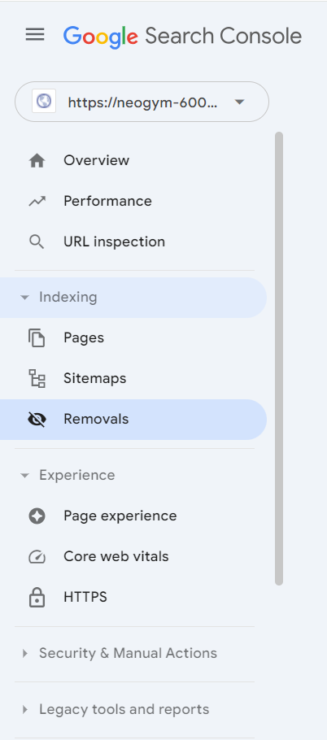

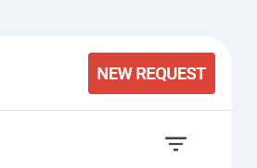

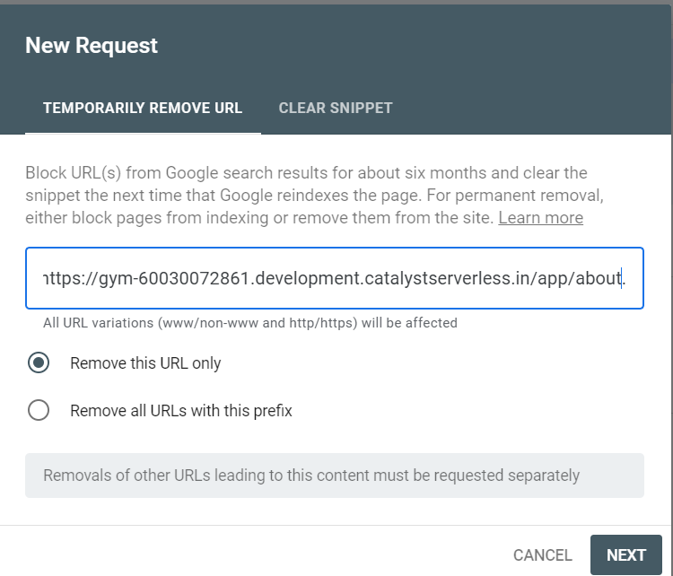

**Remove duplicate images**

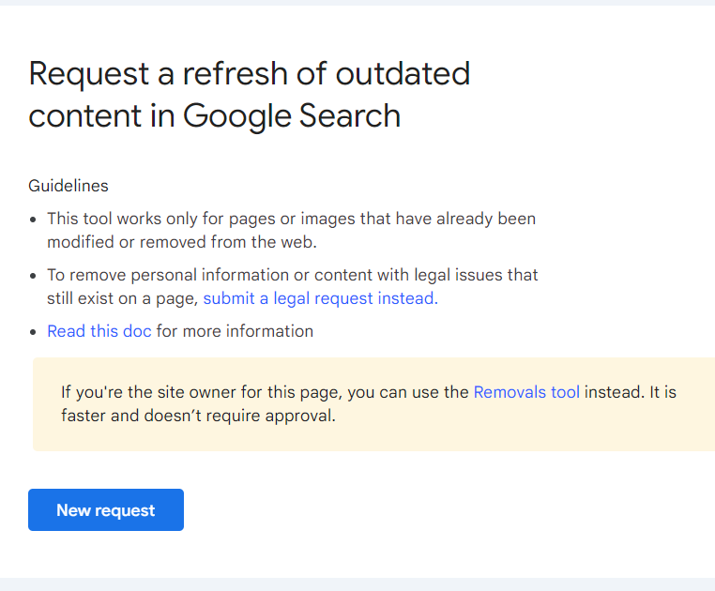

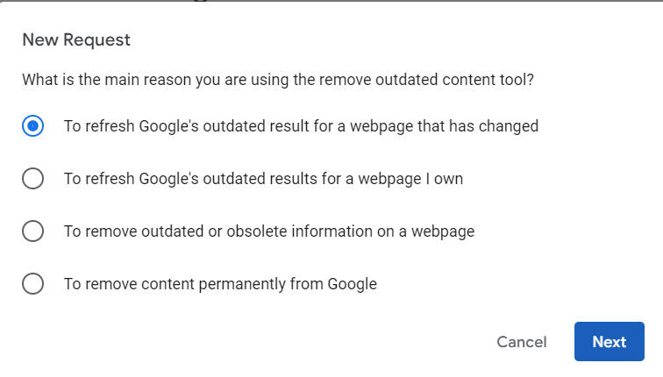

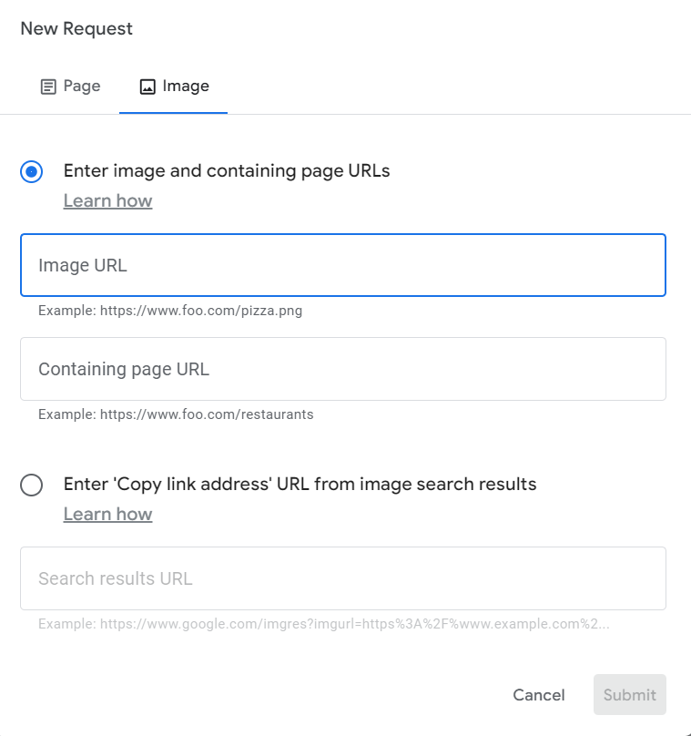

**8.Minify Techniques**

* Minification is the process of removing unnecessary comments, white space, and unused code, as well as the shortening of variable and function names on HTML, CSS and JavaScript (JS).
* Minification is a fast and easy way to reduce a website resource usage, this techniques can improve the time needed to render a page by over 60%.

**Type of Minification Techniques**

1. HTML minification

2. CSS minification

3. JavaScript minification

**Online Tool**

<https://beautifytools.com/>

**9.Disavow Backlinks**

* Disavow tool is part of Google Search Console that allows websites to discount the value of an inbound link, helping to prevent against link-based penalties.
* Disavow is the process of instructing Google to ignore unwanted backlinks in order to positively impact ranking in SERPs.
* Use only If you believe that there are a considerable number of spammy, artificial, or low-quality links pointing to your site.

**Create a list of links to disavow**

1. Specify one URL to disavow per line, such as [example.com/](http://example.com/)
2. The file name must end in .txt
3. Maximum URL length is 2,048 characters
4. Maximum file size is 100,000 lines (including blank lines and comment lines) and 2MB.

# Two pages to disavow

<http://example.com/stuff/comments.html>

<http://example.com/stuff/paid-links.html>

#One domain to disavow

domain:[example.com](http://example.com/)

**How long does it take to disavow?**

* The effect of a disavow link takes anywhere from a few days to process and up to 2-3 months for you to start seeing results.
* If you've been struggling with bad spam links damaging your traffic, you need to respond quickly.

Backlink Checker Tool:

<https://www.seoreviewtools.com/valuable-backlinks-checker/>

Disavow Links Tool Page:

<https://search.google.com/search-console/disavow-links>

**10.Page Speed Test**

* A fast-loading page speed will help your SEO efforts, Google recommended page load time is under 2-5 seconds.
* Slow loading speed can also affect SEO indirectly by increasing bounce rate and decreasing time users spend on your site.
* Loading speed is one of the ranking factor for Google, So your site won't get much organic traffic if it's slow.

**Website Speed Testing Tools**

Page Speed Insights

<https://pagespeed.web.dev/>

GTmetrix

<https://gtmetrix.com/>

**11.Mobile-Friendly Test**

* Mobile Friendly means that your website (or app) looks good and performs well on a smartphone or tablet.
* To considered mobile friendly, your site needs to be fast, simple, and easy to use no matter what device the reader is using.
* Google announced in 2015 that they would be "boosting the ranking of mobile-friendly pages on mobile search results."

**Mobile Friendliness Tests Tools**

Page Speed Insights

<https://pagespeed.web.dev/>

Chrome Extensions

Mobile simulator - responsive testing tool